1.How to invoke a funtion?

In other words can also be said as , calling a function

ex:function myFunction() {

return a \* b;

}

to invoke the above funtion can use myfunction();

or else can use other inbuilt funtions which calls other functions by themselves.

2. Difference between break and continue.

break will totally jump out the loop after reaching a specific condition mentioned by the programmer

continue will break the loop but just the current iteration and continues to the next loop until reaching the end condition.

3. Function types with example.

Named Functions-

ex:Function myFunction() {

return a \* b;

}

has a name and can be invoked by using the name of funtion.

Anonymous or arrow function-

ex:function myFunction( ()=>{console.log(1);

console.log(2);}) {

return a \* b;

}

doesn't have a name to function,

name can be assigned later.

4. String methods with example-

String length

text="Hello World!"

text.length=12.

Splice()

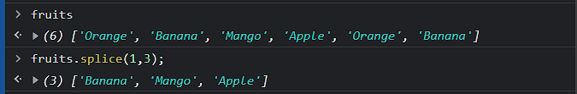

Substring()

 str = "Apple, Banana, Kiwi";

 part = str.substring(7, 13);

replace()

text = "Please visit Micro";

new = text.replace("Micro", "soft");

o/p-"Please visit soft";

/g- is used globally to replace all existing string with another string.

toUpperCase and toLowerCase

 text1 = "Hello World!";

 text2 = text1.toUpperCase();

op-“HELLO WORLD”

toLowerCase

 text1 = "Hello World!";

 text2 = text1. toLowerCase();

op-“hello world”

concat();

text1=”hello”

text2-“world”

text1.concat(text2);

op-helloworld;

trim()

let text1 = " Hello World! ";

let text2 = text1.trim();

text1.length=14

text2.length=12

padstart()

text = "3";

text2= = text.padStart(4,"x");

op-xxx4.

padend()

text = "3";

text2= = text.padend(4,"1");

op-4111

5.Difference Between replace( ) and replaceall( ).

Replace( )

text=I have written a program for program task

text2=text.replace(‘program’,”test”);

op-text2= I have written a test for program task

replaceAll( )

text=I have written a program for program task

text2=text.replaceall(‘program’,”test”);

op-text2= I have written a test for test task

6.Ternary operator-

Contains a condition followed by as ?

If the condition is true:execute a value

If the condition is false:execute a value

Sum=0;

Result=(sum==0)?”yes” : “no”;

Op: “yes”